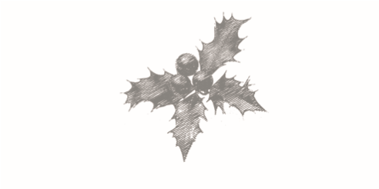

FESTIVE MENU
3 COURSE £28 PER PERSON

STARTERS
A) Watercress & Stilton soup, toasted cumin seeds
B) London Porter smoked salmon, sweet pickled kohlrabi slaw, soft herbs
C) Roasted beetroot, pickled shallots, quinoa, hazelnuts, apple balsamic
D) Ham hock terrine, house piccalilli & toast

MAINS
- Roast Usk Vale turkey breast, chestnut & apricot stuffing, pigs in blankets, turkey gravy, served with honey roasted parsnips & carrots, roast potatoes & buttered Brussels sprouts
- Confit Dorset pork belly, baked Cox's apple, parsnip purée, crispy kale
- Braised beef cheeks, mash, spinach, burnt leeks & braising liquor
- Sea trout, Mrs Owton’s bacon, barley, spring onions, sorrel
- Butternut squash, Laverstoke Park Farm brie & sage shortcrust parcel, roast tomato & tarragon sauce

PUDDINGS
- Black Cab Christmas pudding, Fuller's brandy butter ice cream
- Seville orange chocolate cheesecake, Fuller's orange choc chip ice cream
- Tiramisu roulade, Brewer Street coffee ice cream
d) Pear & almond tart, Fuller's vanilla cream

